Meta Title: Most Reliable custom website development company | Call us!
Meta Description: If you are looking for an expert custom website development company, let us help you. We specialize in creating a diverse range of web solutions.

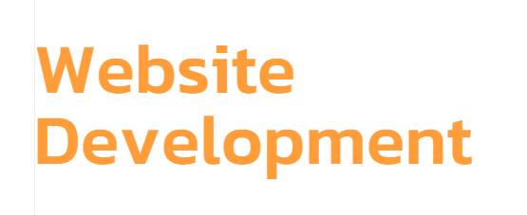

Looking for a custom website development company?
We can help you put your business online and get more sales and leads. Our custom website development company is experienced in all facets of web development. So, we can easily help you reach your maximum digital potential.
Call Today!

Ours is the best custom website development company!
At The Neo Solution, we provide you with cross-platform and responsive web development solutions. You can count on us to craft websites that display properly on all screen sizes and in all browsers. Whether your user is on the PC, mobile, or a tablet, the website we develop will keep them engaged. We do:
Frontend Development | Backend Development |  | Full Stack Development
At our custom website development company, we have the most skilled developers who use front-end frameworks like React.js, Vue.js, and Angular. | Using server-side technologies like Ruby on Rails, Python, and Node.js, we produce fast and scalable web solutions for prototyping and development. |  | You can count on our custom website development company to deliver end-to-end products with a combination of frontend and backend.
Low-Code Development |  | Cloud Development
Our custom website development company also specializes in low-code and no-code web solutions that save you time and money. |  | We deliver you fast and secure web solutions using cloud services like Google Cloud, Amazon Web Services, and Microsoft Azure.

Technologies we use:

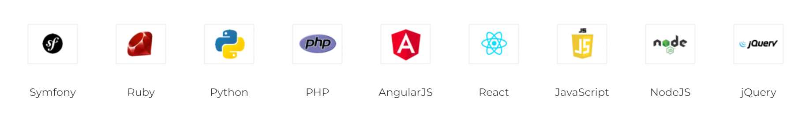

Why choose our custom website development company?
At The Neo Solutions, we develop websites on test servers so that you can mark the progress and experience the site in real time. This way, we help you visualize the site and give feedback for changes before it goes live. We host the site on our server – until fully developed. What’s more, unlike any other custom website development company, we test, update, and refine our development processes. The websites that we design have:
- Custom features per your requirements
- Easy-to-navigate & engaging UI/UX design
- Very high-end & responsive design
- Scalability and industry-standard security
- Ongoing maintenance & support from us

Custom Website Development Company

That offers streamlined development process
Outmatching every other custom web application development company, The Neo Solutions has been delivering web development services for years now. The best aspect of our web development is that we align strictly to deadlines and have a clear and effective development procedure. Here’s how the process goes:

Consultation
We will create a brief for your requirements and make technical documents for early-stage prototypes. This lays the foundation of our entire development process.

Development
We will create your website with you in the loop – regular updates and feedback incorporated – unlike any other custom front end web development company.

Support
Once your website is live, we perform continuous server monitoring, fix bugs, and provide general customer support. You can count on us for reliable support.

Updates
Unlike any other custom or eCommerce website development company, we also provide you with regular feature updates to help meet user demands.

Industries we serve:
Retail | Manufacturing | Education
Healthcare | Entertainment | Hospitality
Tourism | Real Estate | Travel
Finance | Banking | It Industry

Let’s make your web development project a success!
Take advantage of our web development services! Our team of expert developers pays attention to every subtle detail to develop the best web-based solutions for you. Till now, we have delivered countless projects. Clearly, we know how to execute a seamless web development process.
CMS, WordPress, Drupal | eCommerce Solutions | PHP & JS Web Development
You can count on us to develop a content management system (CMS) to help you manage your site content effectively. | If you need shopping cart software and eCommerce sites, our company can provide you with the best web solution. | Looking for a Nodejs web development company? We provide development in PHP, Python, JavaScript/ jQuery and other technologies.

Your go-to for engaging & high-performance Websites!
You no longer need to look for a specific Reactjs or backend web development company because we provide custom, full-stack web solutions. You can rely on us to develop the website of your dreams.

Consult your ideas

Choose a technology

Design & Develop

Reach the Market

